

**Changing Internet Setting with Microsoft Edge**

Steps to ensure the PDF settings are turned on to download PDF files.

1. Open Microsoft Edge, go to Setting, click Cookies and site permissions, then PDF Documents:

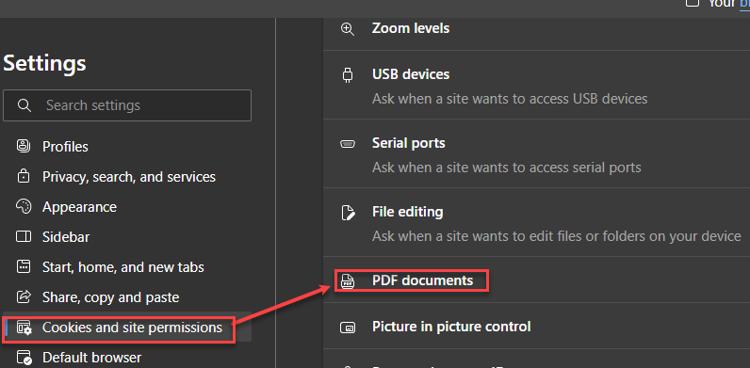

1. Confirm both site permissions are turned on:

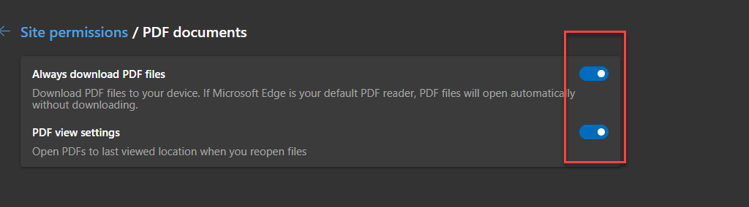

1. In Settings, click Privacy, search, and services, then Clear browsing data:

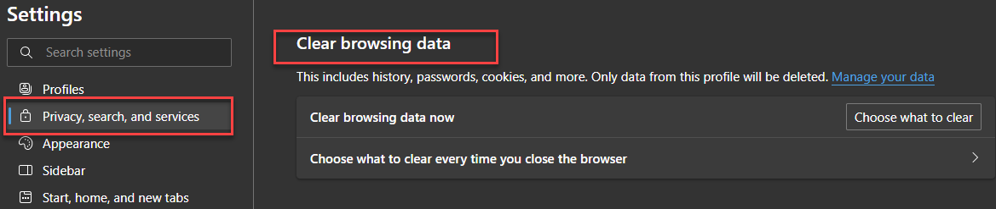

1. Click this test [link](https://www.metlifeadminmanual.com/content/dam/MetLife/adm-ga-forms/enrollment-form-generator-guide---brokers-and-customers/Enrollment_Form_Generator_Guide_for_Brokers_and_Customers.docx), the document will be downloaded within the Download window on the Edge screen:

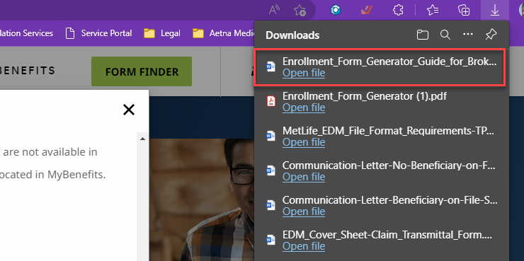

1. Click the [Enrollment Form Generator](https://www.metlifeadminmanual.com/content/dam/MetLife/adm-ga-forms/enrollment-form-generator/Enrollment_Form_Generator.pdf) link, which will open in the Edge download screen.