cid:image001.png@01D2AEC4.4802ECE0

**ENROLLMENT FORM GENERATOR GUIDE**

**FOR BROKERS AND CUSTOMERS**

This guide will assist you in determining if the Enrollment Form Generator can be used to build the MetLife enrollment form. Each section is important and should be read in its entirety.

There are 3 steps to generate the enrollment form using the Enrollment Form Generator:

1. Build the form (completing the generator)
2. Review the form (proofreading)
3. Finalizing and saving the form (to your desktop)

**?**

Refer to Contact Us within the Administration Manual

if you have any questions.

**Guide Contents**:

*Limitations*

*Use the Generator to Build the Enrollment Draft*

*Proofread the Draft*

*Finalize the Enrollment Form*

*Frequently Asked Questions*

*Definitions*

**! Important** **There are situations where using the Enrollment Form Generator is prohibited. A custom form maybe required or State Requirements do not allow the coverage.**

**Limitations**

**Do not use this tool for:**

* 1,000+ employee groups
* **DHMO** (Dental Health Maintenance Organization enrollment forms are in the Form Finder)
* **2-9 Lives** - Supplemental Life (buy Up), Standalone AD&D, VSTD and Voluntary Coverages: Accident, Critical Illness (all) and Hospital Indemnity
* **Dental or Vision** (Groups situs in **Florida and Washington 2-50 Lives**)
* **Hyatt only coverage**, unless sold with other coverages
* Group Universal Life (**GUL**)/ Group Variable Universal Life (**GVUL)**
* **Property & Casualty**
* Worksite Short Term Disability (**WSTD**)
* For **Voluntary Coverages**, if state requirements do not allow the coverage, Employers cannot be sitused in the following states/jurisdictions for these coverages:

**NOTE:** Please refer to the lower-left-hand corner of the cover page of your Cost & Benefit Summary (C&B) or Certificate of Insurance. If the Critical Illness C&B has a “CI-19” indicator or the Certificate has a “GCERT19-CI-fp” or Hospital Indemnity C&B has a “HI-16” or the Certificate has a “GCERT16-HI-fp” indicator, please select the enrollment form for use with Critical Illness 19 or Hospital Indemnity Insurance 16.

|  |  |  |  |  |  |  |  |  |  |  |  |
| --- | --- | --- | --- | --- | --- | --- | --- | --- | --- | --- | --- |
| **States/Jurisdictions** | **Accident** | **Critical Illness** | | | | | | **Hospital Indemnity** | | **MetLife Legal Plans** | **Vision** |
| **3.5 Attained Age** | **3.5**  **Issue Age** | **3.5**  **Issue Age Cancer** | **CI-19**  **Attained Age** | **CI-19**  **Issue Age** | **CI-19**  **Issue Age**  **Cancer** | **(HI12)** | **(HI16)** |
| **Commonwealth Northern Mariana Islands (MP or CNMI)** | x | x | x | x | x | x | x | x | x |  |  |
| **Guam (GU)** | x | x | x | x |  |  |  | x | x |  |  |
| **Indiana (IN)** |  |  |  |  | x | x | x |  |  |  |  |
| **New Jersey (NJ)** |  |  |  |  | x | x | x |  |  |  |  |
| **New Hampshire** |  |  |  |  |  |  |  |  | x |  |  |
| **New Mexico (NM)** |  |  |  |  |  | x |  |  |  |  |  |
| **New York (NY)** |  |  |  |  | x | x | x | x |  |  |  |
| **Puerto Rico (PR)** | x | x | x | x | x | x | x | x | x | x |  |
| **Virgin Islands (VI)** | x | x | x | x | x | x | x | x | x |  | x |

Residents (Employees) of the above may be covered under an Employer group plan sitused in an approved state/jurisdiction.

**Enrollment Form Generator: Building the Enrollment Form Draft**

The Enrollment Form Generator is used to create Enrollment and Change Forms where permitted. Restrictions apply and are outlined in the **Limitations** section. Once you have determined that you are permitted to use this tool, proceed with the following steps to build the enrollment form draft.

1. Click this link to access the [**Enrollment Form Generator**](https://www.metlifeadminmanual.com/content/dam/MetLife/adm-ga-forms/enrollment-form-generator/Enrollment_Form_Generator.pdf) (You must have the latest version of Adobe in order to use this tool).

Complete the Enrollment Form Generator fields using the guidance provided below.

**Tip:** The tool is dynamic and options change based on your selections. All of the questions shown below may not appear when you use the generator. Additional questions may appear based on your selections

|  |
| --- |
| * **Edit** - Do not use for MetLife use only |
| * **MetLife employee or Employer/broker?** Select **Employer/Broker** |
| * **Name of Group Customer/Employer:** Optional field |
| * **Group Customer No.:** Optional field |
| * **State -** Select the customer situs state/jurisdiction   **!** **Important:** Read the **Limitations** section above before you continue. |

|  |
| --- |
| * **Coverage Categories -** Select all applicable coverage categories:     **Tip: Voluntary Worksite Benefits** include Accident, Hospital Indemnity, Critical Illness Insurance, Critical Illness Insurance – Cancer Only, MetLife Legal Plans. |
| * **Coverages –** Within each Coverage Categories -Select all applicable coverages.   **Tips:**   * In order to select any dependent life, you must first select the corresponding employee life coverage. * This form prevents overlapping coverage. Combined coverages will display in gray. * STD – only one STD coverage can be selected at a time. * LTD – only one LTD coverage can be selected at a time. * Dental – only one Dental coverage option can be selected at a time. * Vision - only one Vision coverage option can be selected at a time. * MetLife Legal Plans is available only if another coverage is selected; otherwise, it is not available and is greyed out.   **Terminology:**  **Core/Buy Up** – The Insured is offered an initial Core benefit and has the opportunity to Buy Up additional coverage.  **Single/Dual/Triple Option** – Single Option is when the Insured has one benefit option to choose. Dual option is when the Insured has two benefit options from which to choose (i.e., HIGH/LOW). Triple Option is when the Insured has three benefit options from which to choose (i.e., HIGH/MEDIUM/LOW). Only one option can be selected. |

|  |
| --- |
| **The cost of insurance is paid by:**  **Employee (Some/All):**  choose this if the employee pays all or some of the insurance premium for this benefit.  **Employer (All):**  choose this if the employer pays 100% of the insurance premium for this benefit. |
| **Tier –** Choose either (Dental/Vision Coverage):   * 1-Tier - Employee Only * 4-Tier - Employee Only - Employee + Spouse, Employee + Child(ren), Employee + Spouse + Child(ren)   Voluntary Coverages – Choose either:   * 3-Tier - Employee Only, Employee + One Dependent (Spouse or Child), Employee + Two or More Dependents (Spouse and Child(ren)) * 4-Tier - Employee Only - Employee + Spouse, Employee + Child(ren), Employee + Spouse + Child(ren)   **Critical Illness**  **Participant Rates -** Pricing options for the coverage offered to the Insured may include:   * Employee Only * Employee + Spouse * Employee + Children * Employee + Spouse + Children     **New Hampshire (NH) Situs - Is this Critical Illness - Cancer Only plan CI-19?*:** CII or CII Cancer Coverage Only requires you to answer whether or not CI-19 or Cancer 19 product was sold.   * Select **Yes** to generate a standalone NH Situs CI-19 and/or Cancer-19.  **Note:** Prior coverage(s) selection(s) will need to be cleared to generate a New Hampshire CI-19 form only. NH Situs CI-19 and/or Cancer-19 (Critical Illness and Critical Illness-Cancer Only) cannot be paired with any other MetLife products (e.g. Life, Disability, Dental, Vision, 3.5 Critical Illness, Accident, Hospital Indemnity) on the same enrollment form. If you have a multi-product form needs, you may bundle all other MetLife products on a single form and CI-19 (Critical Illness and/or Critical Illness Cancer Only) on a separate form. * Select **No** to generate a NH Situs, Non-CI-19 or Cancer 19 form.         **Smoking Rate Question -** Critical Illness Insurance requires you to answer whether or not there is a smoking rate.   * Select **Yes** if the rate is dependent upon whether the applicant smokes.  Note: For Participants Rates, the smoking rate for a Spouse/Domestic Partner can be based on either the Employee’s smoker status or the Spouse’s/Domestic Partner’s smoker status. * Select **No** if uni-smoker rates apply - the rates are the same whether the Insured is a smoker or non-smoker.   C:\Users\aparr\AppData\Local\Temp\SNAGHTML60152219.PNG |
| **Additional Questions**   * **Domestic Partners** - Displays only when spouse coverage is selected for Dependent Life, Supplemental Life, Dental, Vision, Accident, Hospital Indemnity or Critical Illness.   Note: Domestic Partner does not apply to Disability Income Insurance.     * **Shopper’s Guide** - Displays only when for Critical Illness/Critical Illness Cancer Only coverage is selected. * **90-day Hospitalization -** The question displays only when Supplemental Life is selected. Select: **Yes** if the question applies, then select all participants to whom question applies. If selected, all covered individuals must answer the question.      * **Beneficiary designation declination -** The checkbox displays only upon selection of the coverages outlined in the question.   + **Check** if you would like to exclude the beneficiary designation section from appearing in the form. This is an exception and the beneficiary form must be sent separately.   + **Unchecked** is the standard.      * **Retiree inclusion** - The checkbox displays only upon selection of the coverages outlined in the question**. Check** if retirees are offered any of the listed coverages. |

1. After making the appropriate selections, click the **Build Enrollment • Change Form** button at the bottom of the document.



Results:

* The draft form will generate with a fillable PDF Enrollment • Change Form which includes necessary notices or
* A popup warning will display, informing that selections require additional attention (e.g., coverages selected which cannot be sold together, or missing information for some of the questions). For example, “**The fields highlighted in red are required. They must be completed before this form can be created.**”

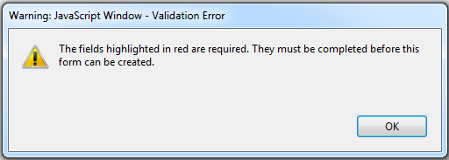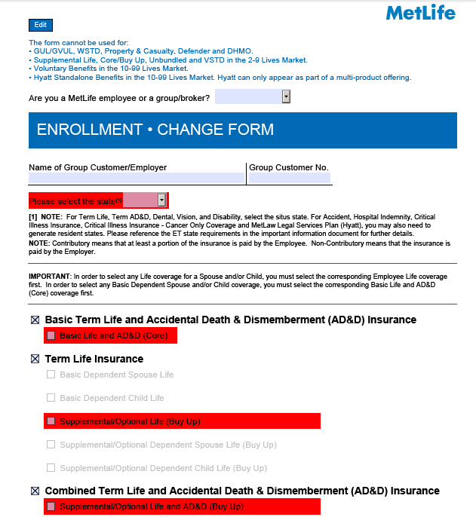

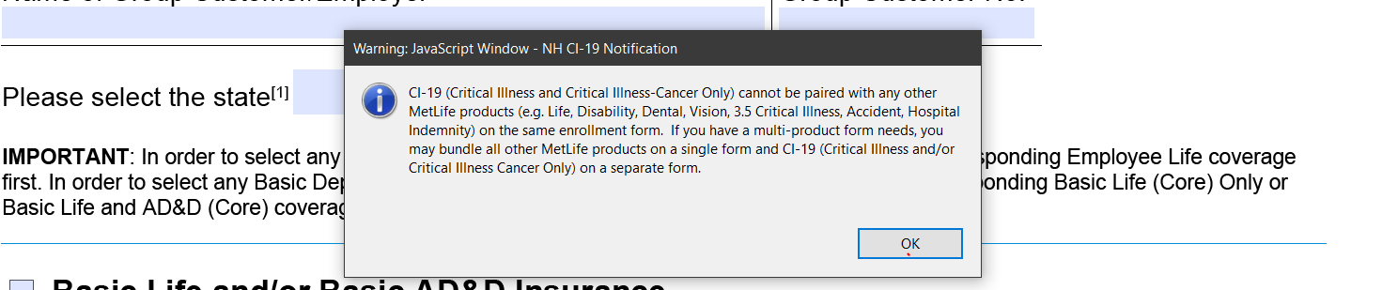

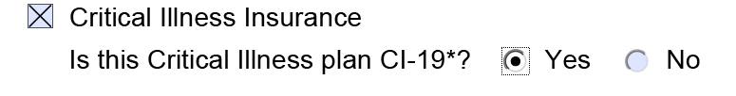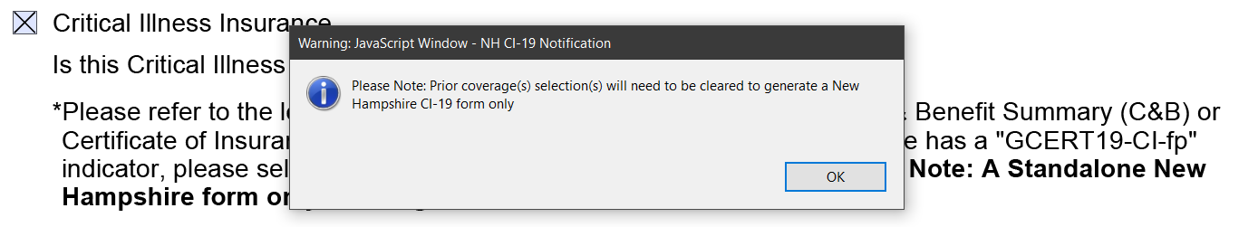

1. If the popup warning appears:

* Press **OK**.
* Complete the required fields. For help review the **Building the Enrollment Form Draft**.
* Click the **Build Enrollment • Change Form** button at the bottom of the document.

1. Proceed to **Proofread the Draft** section.

**Proofread the Draft**

Proofreading before finalizing the form will save you unnecessary work. Once a form is finalized, adjustments cannot be made and an entirely new form would need to be generated. Follow the steps below to proofread the form.

1. Review the enrollment form to verify it is correct and complete.
2. If the form needs to be adjusted (e.g., coverage selections, contributions, plan options), select the **Click Here to make edits to this form** button.

This button appears at the top of each page and also appears at the bottom of the Enrollment • Change Form in the **How to submit this form** section, next to the **FINALIZE FORM** button and prior to the notice pages.

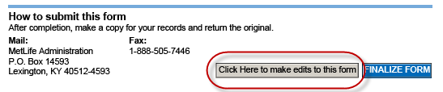

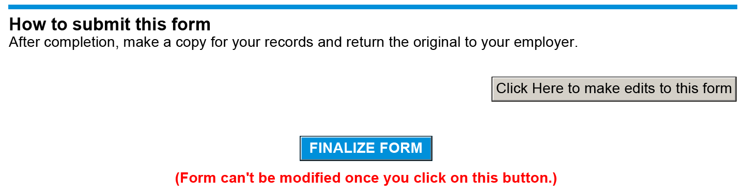

1. Review the form and either: return to the **Building the Enrollment Form Draft** section to adjust your form or continue to the **Finalize the Form**section.

**Finalize the Enrollment Form**

The Enrollment Form should be finalized prior to use it. Finalizing the form creates a static, fillable form.

**! Important Do not finalize the form if adjustments are needed.** Once the form is finalized, the **Click Here to make edits to this form** button disappears and no adjustments can be made. Once finalized, if the form is not acceptable, an entirely new form would need to be generated using the Enrollment Form Generator.

Once you have confirmed the form is acceptable, proceed with the steps below to finalize the form.

1. Click the **FINALIZE FORM** button in the **How to submit this form** section. Result: The form is finalized.

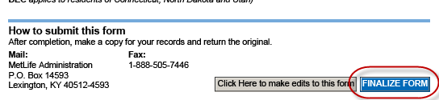



1. Print or save the form by going to the File menu at the top of the PDF.

Note: When saving forms, be sure to use unique file names for each form.

**FREQUENTLY ASKED QUESTIONS**

**Q:** **Can the form be generated for all MetLife coverages?**

**A:** No, the form **cannot** be generated for the following coverages:

* Group Universal Life (GUL)/Group Variable Universal Life (GVUL)
* Worksite Short Term Disability (WSTD)
* Property & Casualty
* Dental Health Maintenance Organization (DHMO

**Q:** **Are there any restrictions based on Customer size?**

**A:** Yes, this form cannot be used for Customers over 1000 lives. In addition, review the Customer size restrictions below:

2-9 LIVES CUSTOMERS - COVERAGES CANNOT BE OFFERED:

* Supplemental Life (Core/Buy up)
* Standalone Accidental Death and Dismemberment (AD&D)
* Voluntary Short Term Disability (VSTD)
* Voluntary Benefits (e.g., Accident, Hospital, Critical Illness, MetLife Legal Plans)

10-99 LIVES CUSTOMERS - COVERAGES CANNOT BE OFFERED:

* Voluntary Benefits (e.g., Accident, Hospital, Critical Illness)
  + - MetLife Legal Plans Standalone: *This product can only appear as part of a multi-product offering.*

**Q: What if I cannot generate a form using this document or have questions when generating an enrollment form?**

**A:** Refer to the Contact Us within the Administration Manual.

**Definitions**

* **Contributory -** At least a portion of the insurance is paid by the Employee.
* **Non Contributory -** Insurance is paid by the Employer.
* **Core Products -** Term Life, Term AD&D, Dental, Vision, and Disability.
* **Voluntary Benefits (VB) Products** **-** Accident, Hospital Indemnity, Critical Illness Insurance, Critical Illness Insurance **-** Cancer Coverage Only and MetLife Legal Plans.
* **Core/Buy up -** Core is when the Insured is offered an initial amount of coverage. Buy up is the opportunity to buy additional coverage on top of the Core offering.
* **Dental and/or Vision Option -** Dental PPO or Vision PPO single plan option.
* **Dental and/or Vision Dual Option -** The coverage has two different plan options to select from (i.e., HIGH/LOW) and based on this election, the benefits covered under these options differ.
* **Dental Triple Option -** The coverage has three different plan options to select from (i.e., HIGH/MEDIUM/LOW) and based on this election, the benefits covered under these options differ.
* **Tier -** An individual the coverage will be offered to. Below are examples of the tiers:
* **1 -Tier -** Employee Only
* **2 –Tier -** Employee Only, Employee + Spouse + Children
* **3 –Tier -** Employee Only, Employee + One Dependent (Spouse or Child), Employee + Two or More Dependents (Spouse and Children)
* **4 –Tier -** Employee Only, Employee + Spouse, Employee +Children, Employee + Spouse + Children
* **Participants Rates -** Employee Only, Employee + Spouse, Employee + Children, Employee + Spouse + Children

**Critical Illness Only:**

* **Smoking Rate -** The rate is dependent upon whether the applicant smokes. For Participant Rates, the smoking rate for a Spouse/Domestic Partner can be based on the Employee’s smoker status or the Spouse’s/Domestic Partner’s smoker status.
* **Issue Age -** Rate is based on the age of the insured at enrollment. The rate will not change.
* **Attained Age -** Rate increases when the insured moves from one age band to another. An age band is a set number of years.